Nothing Became Something
Author: Rev. Guarino

Project Info
App Type: Interactive Story Game
Target Platform: PC

Pitch

Unique Premise
"Nothing Became Something" is an interactive story game where you are caught in a conflict between man and monster in the secret world behind your eyelids at night. Your choices will determine whether the world is destroyed and forgotten by the time you wake.

Fun Factor
The game is meant to appeal to fans of choose-your-own adventure books or episodic story games like Dispatch or many Telltale games, your actions and choices have consequences on your relationships with characters and the outcomes of different events.

Basics

Mechanics
The core mechanic of the game is that players get to choose their dialogue options, and their choices have bearing on the availability of future choices through hidden values and flags. It follows a similar structure to other dating games where progression is tied to the completion of conversations with different characters.

Artistic Style
The artistic style is a grayscale sketchbook-esque world with characters that are vibrantly colored. Character art for three characters with five expressions each has been provided to me by the Twitch streamer "yourdadshouse007”, and she has given explicit permission for it to be used with attribution in this game.

Scale
The scale of the project is best described by the number of conversations and choices available. The "Kinemantik Instant Messenger" system from the game Warframe is serving as a reference for designing conversations with the characters. The current plan is to design the following:
- Act 0: 1 Conversation, 1 Outcome
- Act 1: ~4-8 Conversations, 3 Outcomes
- Act 2: ~8-12 Conversations, ~4 Outcomes
- Act 3: ~8-12 Conversations, ~12 Outcomes

Characters
The player will meet and build relationships with three characters: Floyed, Scarlet, and Raye. Floyed is a natural denizen of the "eyescape" and the player's initial guide. Scarlet is an invader of the "eyescape" and commands a legion of 'volitants' and is an analog for negative or declining health. Raye is also an invader of the "eyescape" but is on the side of 'good' and is an analog for light/day and the ending of sleep.

Design Notes
The story itself features elements and characters that are analogs for real night-time phenomena such as phosphenes, muscae volitantes (eye floaters), eigengrau, palinopsia (afterimages), and similar. The premise is that the player goes to bed at night and the world they see is drawn from the phosphenes they see as they close their eyes. The legions of monsters are 'volitants' i.e. eye floaters.

Publishing
This project in its end-state will be shared via publishing to Steam and marketed via Twitch.

Additional Materials
My Conversation Template (draw.io Snippet)
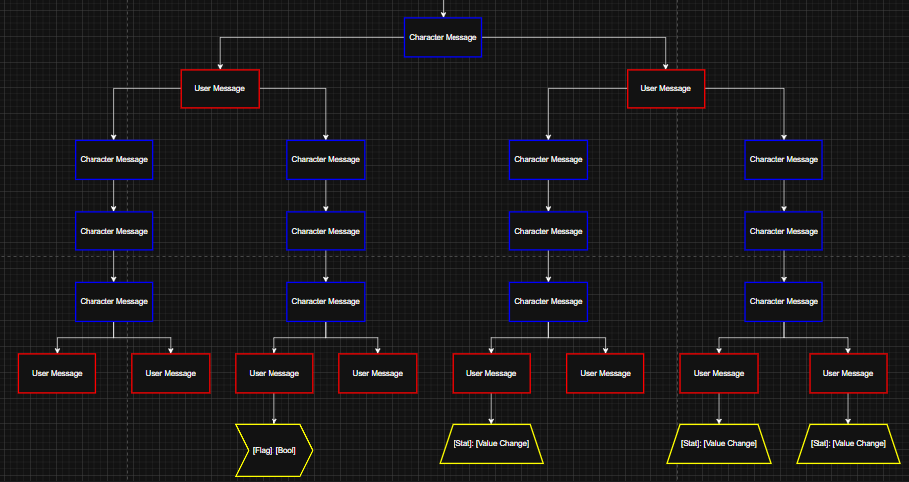
Some Floyed Character Art Attached

